Project Planning Phase
Project Planning Template (Product Backlog, Sprint Planning, Stories, Story points)

Date | 15 February 2026
Team ID | LTVIP2026TMIDS24292
Project Name | LearnHub : Your Center for Skill Enhancement
Maximum Marks | 5 Marks

Product Backlog, Sprint Schedule, and Estimation

Product Backlog & Sprint Schedule
Sprint | Functional Requirement (Epic) | User Story No | User Story / Task | Story Points | Priority | Team Members
Sprint-1 | Registration | USN-1 | As a user, I can register using email and password | 2 | High | Team
Sprint-1 | Registration | USN-2 | As a user, I receive a confirmation email after registration | 1 | High | Team
Sprint-1 | Registration | USN-3 | As a user, I can register using Gmail | 2 | Medium | Team
Sprint-1 | Login | USN-4 | As a user, I can log in using email and password | 1 | High | Team
Sprint-1 | Dashboard | USN-5 | As a user, I can access my dashboard after login | 2 | High | Team
Sprint-2 | Course Management | USN-6 | As a user, I can browse available courses | 3 | High | Team
Sprint-2 | Course Enrollment | USN-7 | As a user, I can enroll in a selected course | 3 | High | Team
Sprint-2 | Learning Module | USN-8 | As a user, I can view course content and videos | 3 | High | Team
Sprint-3 | Assessment | USN-9 | As a user, I can take quizzes after lessons | 3 | Medium | Team
Sprint-3 | Progress Tracking | USN-10 | As a user, I can track my learning progress | 3 | Medium | Team
Sprint-4 | Certification | USN-11 | As a user, I can download course completion certificate | 3 | Low | Team
Sprint-4 | Admin Module | USN-12 | As an admin, I can manage courses and users | 3 | Medium | Team

Project Tracker, Velocity & Burndown Chart

Sprint Tracker
Sprint | Total Story Points | Duration | Sprint Start Date | Sprint End Date (Planned) | Story Points Completed | Sprint Release Date
Sprint-1 | 20 | 6 Days | 01 Feb 2025 | 06 Feb 2025 | 20 | 06 Feb 2025
Sprint-2 | 20 | 6 Days | 08 Feb 2025 | 13 Feb 2025 | 18 | 13 Feb 2025
Sprint-3 | 20 | 6 Days | 15 Feb 2025 | 20 Feb 2025 | 17 | 20 Feb 2025
Sprint-4 | 20 | 6 Days | 22 Feb 2025 | 27 Feb 2025 | 19 | 27 Feb 2025

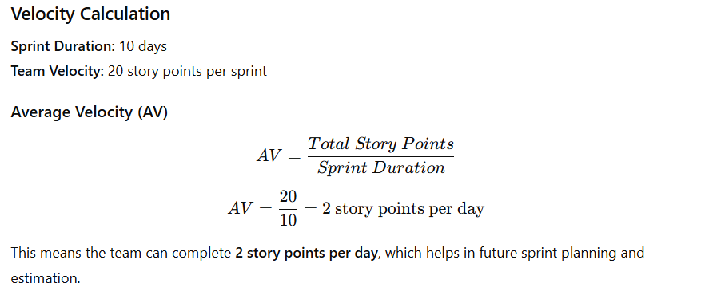Burndown Chart
A Burndown Chart represents the amount of work remaining versus time. It is used to track sprint progress and ensure timely delivery.

Burndown Chart Explanation (for LearnHub)
- X-axis: Sprint duration (days)
- Y-axis: Remaining story points
- The downward trend indicates progress
- If the line reaches zero on the last day, the sprint is successful
For the LearnHub project, the burndown chart helps the team:
- Track daily progress
- Identify delays early
- Improve sprint planning and delivery

Conclusion
The product backlog, sprint planning, velocity, and burndown tracking ensure that the LearnHub project follows Agile best practices. This structured approach enables timely delivery, efficient resource utilization, and continuous improvement across development cycles.

